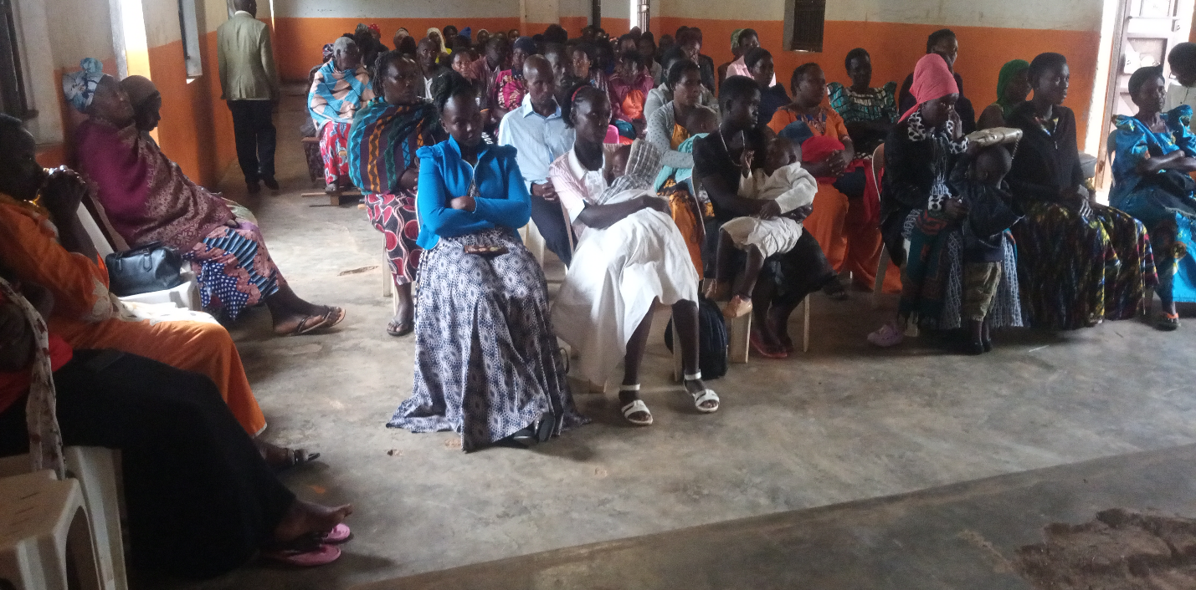
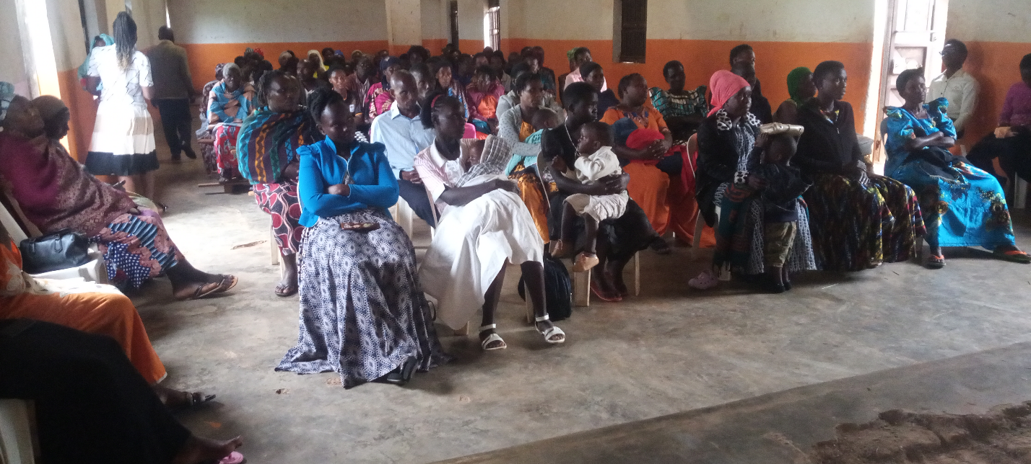
LRK Skills needs based Meetings (Needs Based Analysis- Bukulula)
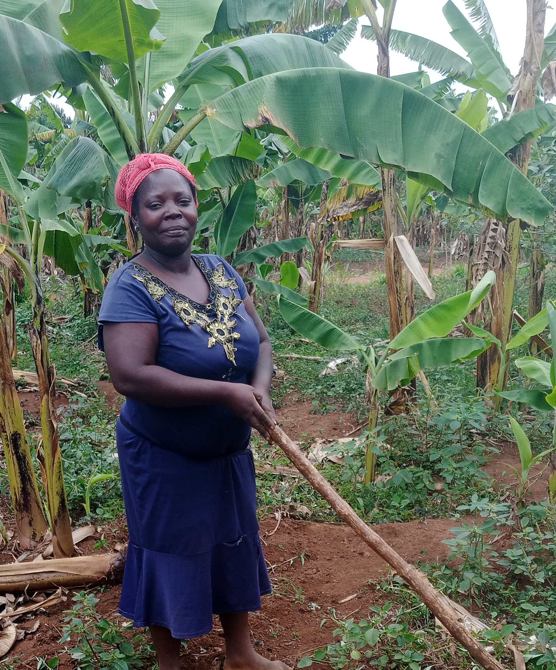
Young woman surviving on crop agriculture for a living- Mukoko Village
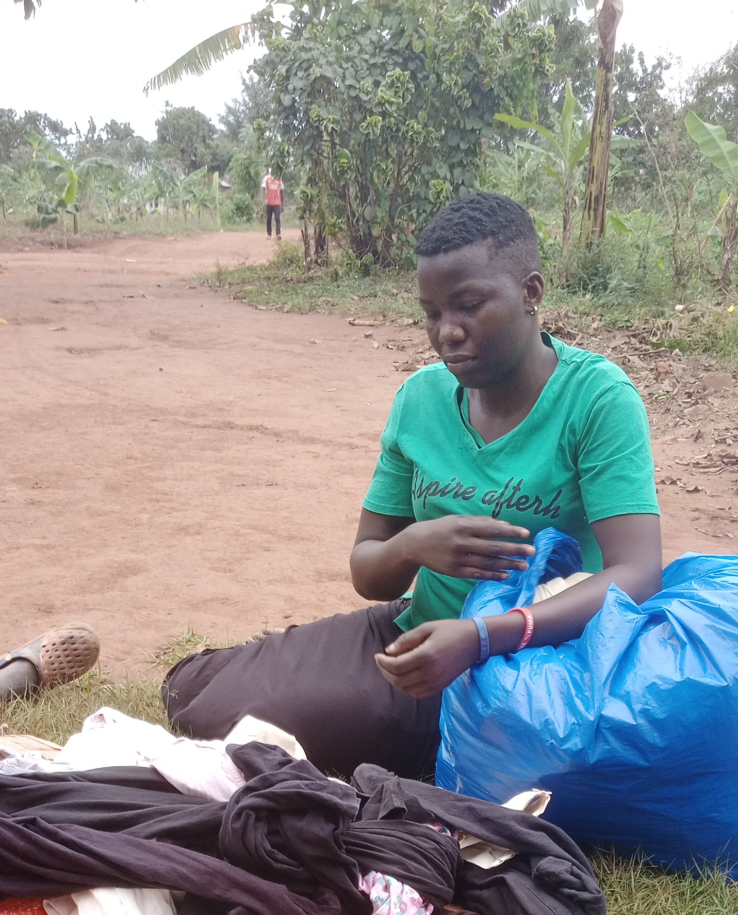
Young woman surviving on whacking second hand clothes as a source of income Kasasa Village.

